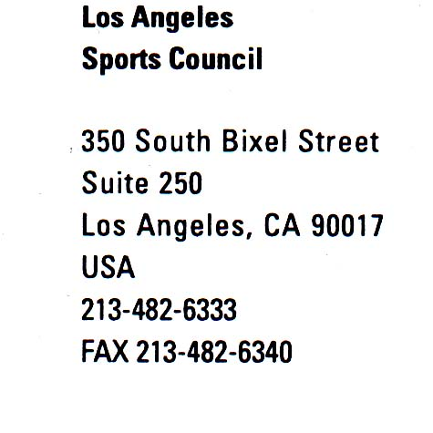
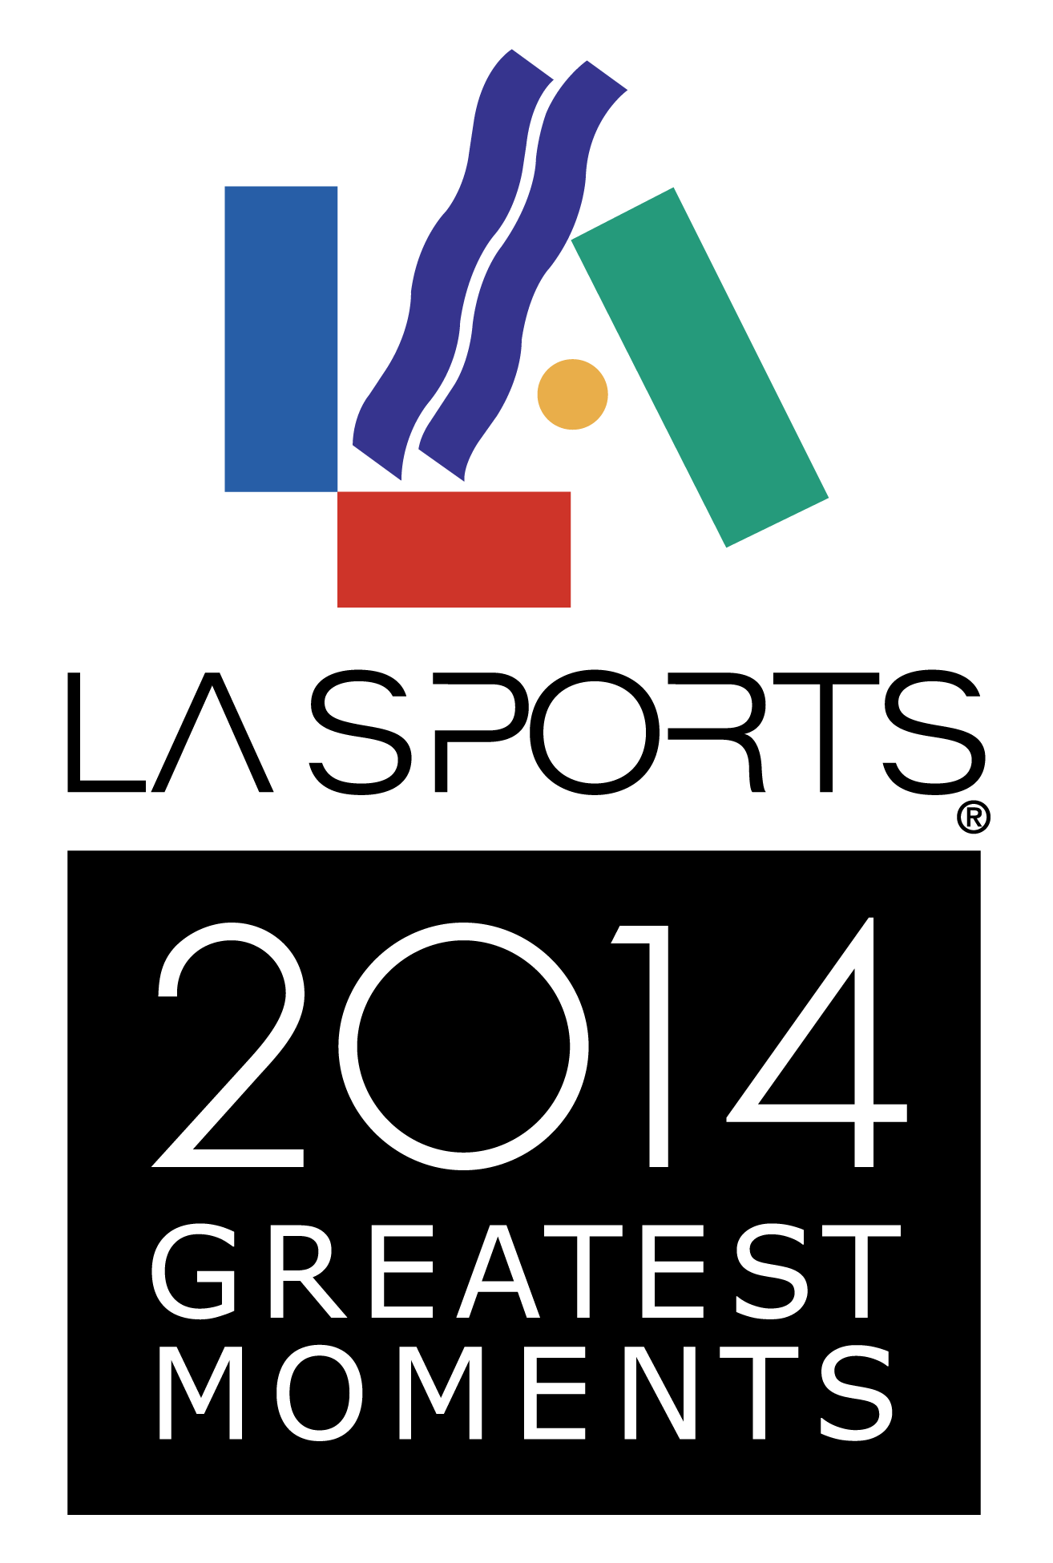

Figure Skating Champion Gracie Gold

Named 2014 Sportswoman of the Year

LOS ANGELES (January 8, 2015) – The Los Angeles Sports Council has named 2014 U.S. Figure Skating Champion and 2014 Olympic Bronze medalist Gracie Gold as the 2014 Sportswoman of the Year. Gold, who resides in Redondo Beach and trains at the Toyota Sports Center in El Segundo with legendary coach Frank Carroll, will be honored during the 10th Annual LA Sports Awards, presented by Coca-Cola, which will be held on Sunday, March 15 at The Beverly Hilton Hotel.
Last year Gold was true to her name as she won her first national figure skating title. Her victory at the U.S. Figure Skating Championships in Boston propelled her to the Winter Olympics in Sochi, Russia, where she helped Team USA win a bronze medal in the team event by nailing her long program.
The LA Sports Awards are presented annually by the Sports Council to celebrate the greatest moments of the year in sports in the Los Angeles/Orange County area. The ceremony also will feature the presentation of the Sportsman, Coach, and Sports Executive of the Year awards, plus a countdown of the year’s Top Ten moments.

The star-studded awards dinner and gala will be televised on Fox Sports West/Prime Ticket (air dates TBA) and will include special appearances by some of the athletes and coaches whose achievements helped make 2014 such a memorable sports year.

Media Contact: Mark Meyers (714) 318-2332
The Sportswoman of the Year award is given to the local female athlete whose performance and character best exemplified the ideals of sportsmanship during the 2014 calendar year. Previous honorees are: Diana Nyad, long distance swimmer (2013); Kerri Walsh Jennings and Misty May-Treanor, beach volleyball (2012); Carmelita Jeter, track (2011); Megan Langenfeld, UCLA softball (2010); Allyson Felix, track (2009); Candace Parker, Sparks (2008); Allyson Felix, track (2007); Lisa Leslie, Sparks (2006); Misty May and Kerri Walsh, beach volleyball (2005).

